Chris Thompson
4/25/17
M.C. Escher
Final Exam
- A general definition of a tessellation is repeating one shape over and over again covering a plane without any gaps or overlaps.
What Escher meant by regular tessellation of a plane is covering an entire plane with a recognizable figure that is repeated creating a rhythmic repetition such as a translation, rotation, reflection, or glide-reflection. These shapes could fill a infinite space if repeated. This quickly became one of Escher’s favorite type of art.
http://cthompeportfolio.weebly.com/tesselations.html
2) Polya was credited to the findings and expanding the 17 different classifications of symmetry groups. Escher was known for finding the 17 different classifications of symmetry groups without any prior knowledge.
http://www.mariuskempe.net/Writing/P%C3%B3lya.pdf

3) Platonic solids are defined as a three-dimensional shape whose faces are all the same shape and whose corners are the meeting place of the same number of polygons.
http://cthompeportfolio.weebly.com/platonic-solids.html

A great example of Escher solids is his lithograph Star. His solids helped to better understand depth by using his artistic skills and including animals and other objects.

4) The telegraph wire effect is the idea that there should be an exchange of straight lines for curved lines and that these curved lines will correspond to our view of space more accurately than straight lines do. These lines continue endlessly on both side creating a lozenge-shaped figure. Although a fascinating discovery, Escher did not use sets of curved lines on their own in any print but proceeded to combine them with relativity of vanishing points in the lithograph High and Low. We see not only curved lines but also zenith for the lower tower and nadir for the upper one.
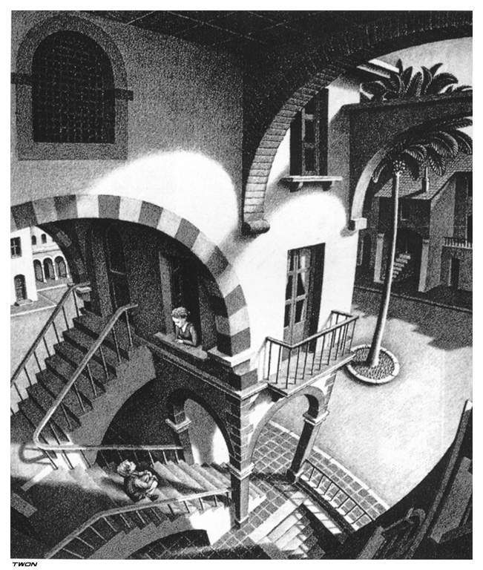

5) In class we mentioned four types of art analysis: Formal analysis, stylistic analysis, iconographic analysis, and historical analysis.
- Formal Analysis- An explanation of visual structure, of the ways in which certain visual elements have been arranged and function with a composition, not meant to evoke the reader's mind. The subject is not considered and neither is the historical or cultural context.
- Stylistic Analysis-Comparing works of different art, looking for resemblance to one another, and then creating a definition of their style based on what you see.
- Iconographic Analysis-Explain visual elements in the work, along with establishing the meaning of a work of art at the time it was made. Also used to explain the meaning of a group of related works.
- Historical Analysis-Looking at how an art piece fits into surrounding culture, its economic import, or what is may reveal about social and political issues of the period.
6) Ekphrasis- make the reader envision the thing described as if it were physically present by describing the image in great detail.
7) In our Art of M.C. Escher class, we were able to put his work in context by examining how experiences in his life helped him to become the artist he is known as today, his work with impossibility, mathematics, and other unique designs. By studying these individual aspects of Escher, I was able to better appreciate not only the artwork of Escher, but by doing these projects such as linocuts and abstract art, I got a taste of how complicated making art can be. I was able to gain knowledge about terms such as tessellations and platonic solids and further understand how brilliant of a man Escher was. He was able to include the right amount of math in his work so that it was still appealing and not overly complex.
8) I believe M.C. Escher was not critically acclaimed for a number of reasons. First, his work was not typical for the time period. Many of his paintings did not resemble the work of other artist of the time period. Second, his art was not sophisticated enough for math critics and from an art perspective, his work was too simple. Many art critics believed his work did not show the proper amount of detail of use of colors. Math critics may have believed that his knowledge of shapes and lines were not enough.

M.C. Escher was publically acclaimed for his uniqueness as an artist. For example, his work with impossible object appeals to us because of the difficulty we have while trying to understand what to make of the image. I believe he was publically acclaimed also for how his work moves us emotionally. This is what appeals to the general public. Work that deals makes us feel a certain way and is perhaps relatable to us. This although means nothing to art critics. They look much deeper into an image. Detail, color, and contrast are amongst the things that make a piece critically acclaimed.

9) A thesis is a statement or presumption, typically in the introduction of your paper, which explains the point your paper is trying to prove.
- I believe one strength of my thesis was that it was clear and easy to understand and properly placed in the paper.
- One weakness of my thesis is that it was overly broad. I should have chosen a much narrower topic to write about. Also, my thesis failed to make a claim or raise specific issues for the paper to explore. Lastly, it was perhaps to common. Much research has been done already on the topic.
- I believe my thesis was fairly well defended. Much of my research started from our book and from there I used online articles and web links to further explore the topic. I do not believe I spent enough time researching my topic as that was a big weakness of my paper. The seven sources I used were all very detailed and provided me with an immense amount of knowledge.
10)
http://cthompeportfolio.weebly.com/research-paper.html
The peer reviews along with the writing center found the tremendous amount of punctuation, spelling, and citation errors my paper had. The writing center made my paper sound a lot smoother and substituted words to make it much more readable and easy to understand.The biggest change the writing center suggested I make was my many uses of the M.C. Escher’s name! I used a different name almost every paragraph without even realizing I did it.

Samuel also helped me with sentence fragments and punctuation in my sentences. He advised me to take out as well as put in a number of words to more clearly present my research.

